CAS PY 106

PreLecture Note 29

1. Differences between lenses and mirrors
2. What differences can you think of between lenses and mirrors?
3. Light reflects from a mirror. Light goes through, and is refracted by, a lens
4. Lenses have two focal points, one on either side of the lens. Mirrors only have one
5. Convex mirrors diverge parallel rays, while concave mirrors converge them. In general, convex lenses converge parallel rays, while concave lenses diverge them
6. What similarities can you think of between lenses and mirrors?
7. The equations we use for mirrors all work for lenses
8. Converging lenses are much like converging mirrors. Both converge parallel rays to a focal point, have positive focal lengths, and form images with similar characteristics
9. Diverging lenses are much like diverging mirrors. Both diverge parallel rays away from a focal point, have negative focal lengths, and form only virtual, smaller images
10. The thin-lens equation
11. Drawing a ray diagram is a great way to get an idea of what is going on.
12. We can also calculate distances and heights precisely using the thin-lens equation, which is derived from the geometry of similar triangles

1 / f = 1/d0 + 1/di

1. It can be written as di = do\*f / (d0-f)

Where do is object distance and di is image distance

1. It’s the same equation we use for mirrors
2. The focal length
3. The focal length of a lens is determined by the lensmaker’s equation:

1/f = (nlens/nmedium – 1) \* (1/R1 + 1/R2)

1. The R’s are the radii off curvature of two surfaces (+ for convex, - for concave)
2. 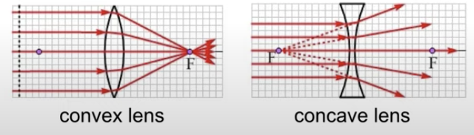
3. Magnification
4. M = image height / object height = hi/ho = di/do
5. If m is positive, the image is the same orientation as the object
6. If m is negative, the image is inverted compared to the object
7. If the magnitude of m > 1, the image is larger than the object
8. If the magnitude of m < 1, the image is smaller than the object
9. The sign convention
10. Where the light goes defines what is positive for objects and images
11. If the left side is positive for objects, the right side is positive for images because the light goes through the lens
12. F, the focal length, is positive for a converging lens, and negative for a diverging lens
13. 
14. When the image distance is positive, the image is on the opposite side of the lens as the object, and it is real and inverted
15. A negative m means that the image is inverted
16. 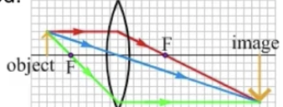
17. When the image distance is negative, the image is on the same side of the lens as the object, and the image is virtual and upright
18. Positive m means an upright image
19. 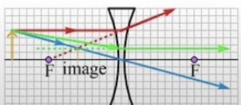
20. A method for analyzing lens problems
21. Solving a lens problem means determining where the image is, and determining what kind of image it is (real or virtual, upright or inverted)
22. Draw a ray diagram 🡪 where the image is
23. Apply the thin-lens equation to determine the image distance
24. Drawing a ray diagram for lenses
25. There are three common rays we draw for lenses, because we know what those rays do when they interact with the lens
26. 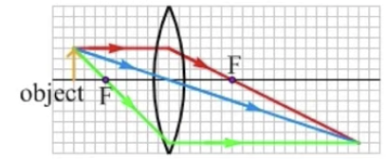
27. The parallel ray (in red) is drawn from the tip of the object parallel to the principal axis. With a converging lens, this ray passes through the focal point on the far side. With a diverging lens, this ray is directed away from the focal point on the near side
28. The ray in blue is drawn leaving the tip of the object, passing straight through the center of the lens without changing direction. This is an approximation – the thinner the lens, and the farther away the object is, the closer this is to what really happens
29. The ray in green connects the tip of the object and the other focal point. Upon reaching the lens, the ray changes direction so that it is parallel to the principal axis